Developing an Information Credibility Scale for Social Media and AI-generated Content: Insights from Expert and User Reviews
Choi, Wonchan | School of Information Studies, University of Wisconsin-Milwaukee, USA | wchoi@uwm.edu
Zhu, Liya | School of Information Studies, University of Wisconsin-Milwaukee, USA | liyazhu@uwm.edu
Lee, Hyun Seung | School of Information Studies, University of Wisconsin-Milwaukee, USA | lee649@uwm.edu

Abstract
This study initiated the development of a new scale to measure perceptions of information credibility on the web, distinguishing between trustworthiness and expertise as core dimensions. Building on a previous analysis of the literature on credibility assessments of information on social media, we generated a pool of 15 items, six for trustworthiness and nine for expertise. Following established scale development guidelines, we refined the scale through expert reviews and cognitive interviews with users. Experts (n = 2) rated most items as highly relevant and offered suggestions for refinement, such as including new items. Users (n = 9) confirmed item clarity but raised concerns about certain terms and perceived objectivity. These preliminary findings support the scale’s relevance and will inform revisions for subsequent validation. Ongoing work will expand participant feedback and move toward large-scale empirical testing.

KEywords
information credibility, web credibility, scale, social media, AI-generated content

Introduction
Assessing information credibility is a critical aspect of how users evaluate, select, and share digital content in today’s complex information environment, in which content is often created and circulated by anonymous users and generative artificial intelligence (AI)-powered agents (Choi et al., 2025; Savolainen, 2023). Our previous literature analyses identified several limitations in existing credibility measures, including inadequate consideration of the multidimensional nature of credibility, unclear distinction between formative and reflective indicators, and insufficient empirical validation reflecting the unique characteristics of the current and newly emerging web environments, in which anonymous users and AI-enabled agents generate content on various types of social media (Choi et al., 2024). These limitations underscore the need for developing a new information credibility scale.
We initiated the development of a new scale for measuring information credibility perceptions tailored to current digital information environments based on established guidelines (Boateng et al., 2018; DeVellis & Thorpe, 2022): (1) determine what is being measured; (2) generate an item pool; (3) determine the format for measurement; (4) have experts review the initial item pool; (5) conduct cognitive interviewing; (6) consider inclusion of validation items; (7) administer items to a representative sample; (8) evaluate the items; and (9) optimize scale length.

Step 1: Defining Constructs
The overarching construct to be measured by the scale is information credibility, defined as the degree of confidence or weight assigned to an information object (e.g., social media post or AI chatbot response) based on its perceived trustworthiness and expertise (Hovland et al., 1953). Both dimensions are essential—without one, the object is not perceived as credible. Trustworthiness refers to the extent to which information is perceived as unbiased and free from intentional manipulation, fabrication, or hallucination; expertise is defined as the extent to which information is perceived as accurate, in-depth, and reflective of domain-specific knowledge. This definition differs from traditional source credibility in interpersonal communication settings or web credibility of static websites, which assume identifiable human sources or site operators (e.g., institutions). In today’s digital environments—especially on Web 2.0 and emerging platforms—information is often generated by anonymous users or AI agents, making source identification difficult.

Step 2: Generating an Item Pool
We developed an initial item pool by analyzing journal and conference papers in information, library, and computer science (including information systems and interdisciplinary applications) indexed in Web of Science. Through multiple group discussions, we identified 22 reflective indicators (i.e., scale items representing the effects of credibility perceptions) and 31 formative indicators (i.e., items contributing to the formation of credibility). Details of our methods and findings are reported elsewhere (Choi & Zhu, 2023; Choi et al., 2024). Based on further review, we finalized the reflective indicators into two sets: six items for trustworthiness (genuine, unbiased, fair, sincere, benevolent, and objective) and nine for expertise (accurate, convincing, correct, valid, pertinent, justified, informative, intelligent, and insightful).

Step 3: Determining the Format for Measurement
To help participants respond more easily in context, we phrased each item as a descriptive statement and asked participants to indicate their level of agreement, rather than rate abstract adjectives directly. For example, instead of asking about the fairness of information (e.g., 1 = not at all fair to 5 = extremely fair), we asked participants to rate statements such as: “The information object fairly represents multiple perspectives” on a 5-point Likert scale (1 = strongly disagree to 5 = strongly agree). We selected an odd-numbered scale to include a neutral midpoint (i.e., neither agree nor disagree) if respondents are unsure or find the item difficult to assess. This approach was applied across all items (Figure 1).
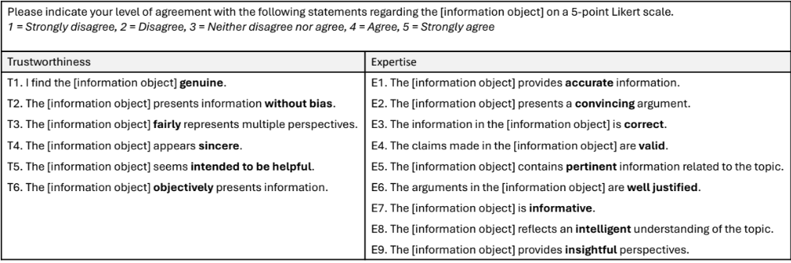 Figure 1. Initial Scale Tested
The present study focused on Steps 4 and 5: testing and refining the scale based on expert and user reviews in preparation for empirical validation. This poster presents preliminary findings from those reviews and addresses the following research question: How relevant and clear is each item for assessing information credibility according to experts and users?

Methods
We recruited participants for two reviewer groups—experts and users. Eligibility for the expert group was defined as researchers with at least one peer-reviewed publication related to information credibility. Participants for the user group were eligible if they had prior experience using social media or AI tools to seek information. In the current study, the expert group included two iSchool faculty members (n = 2) and the user group included nine students (n = 9) with different academic backgrounds: one undergraduate (management information systems), one master’s student (mechanical engineering), six PhD students (information science and education), and one postdoc (physics).
Experts completed an online questionnaire via Qualtrics, reviewing 15 proposed items assessing trustworthiness and expertise (Figure 1). They rated each item’s relevance on a 4-point scale (Kyriazos & Stalikas, 2018) and provided suggestions for improvement. The questionnaire took about 15 minutes. User feedback was collected through one-on-one interviews. Participants reviewed the scale (Figure 1) and discussed each item’s relevance, clarity, and wording. Interviews lasted approximately 15 minutes.

Findings and Future Directions
Expert ratings indicated strong support for the proposed items. Both experts rated all six trustworthiness items as highly relevant (4), except for T5, which received one 4 and one 2. For the nine expertise items, all were rated 3 or 4, which is considered acceptable (Kyriazos & Stalikas, 2018). Experts also suggested additions, such as “consistency” for trustworthiness and “depth” and “clarity” for expertise, but recommended no deletions.
Interviewees generally found the items relevant for assessing information credibility. However, some had difficulty understanding the term “pertinent,” and one questioned the distinction between “accurate” and “correct.” These findings suggest a need for clearer definitions. Also, some participants viewed trustworthiness and expertise as objective qualities and felt that some terms like “unbiased,” “sincere,” and “convincing” were too subjective. These findings highlight the need to clarify that the scale is designed to measure users’ perceptions of information—subjective judgements formed during interactions with information objects (Rieh, 2017).
We will continue collecting expert and user feedback to refine the scale. Following development guidelines (DeVellis & Thorpe, 2022), we aim to recruit approximately five experts and 15 users, or until we reach thematic saturation. Next, we will conduct large-scale data collection to assess the scale’s reliability and validity.

Generative AI Use
We confirm that we did not use generative AI tools or services to author this submission.

AUTHOR ATTRIBUTION
Wonchan Choi: conceptualization, methodology, investigation, data curation, formal analysis, supervision, visualization, writing – original draft, writing – review & editing; Liya Zhu: conceptualization, methodology, investigation, formal analysis, writing – review & editing; Hyun Seung Lee: conceptualization, methodology, investigation, formal analysis, writing – review & editing.

References
Boateng, G. O., Neilands, T. B., Frongillo, E. A., Melgar-Quiñonez, H. R., & Young, S. L. (2018). Best practices for developing and validating scales for health, social, and behavioral research: A primer. Frontiers in Public Health, 6, 149. https://doi.org/10.3389/fpubh.2018.00149
Choi, W., Bak, H., An, J., Zhang, Y., & Stvilia, B. (2025). College students’ credibility assessments of GenAI‐generated information for academic tasks: An interview study. Journal of the Association for Information Science and Technology, 76(6), 867–883. https://doi.org/10.1002/asi.24978
Choi, W., & Zhu, L. (2023). Preliminary findings on developing a scale for credibility assessment on interactive web platforms. Proceedings of the Association for Information Science and Technology, 60(1), 929–931. https://doi.org/10.1002/pra2.901
Choi, W., Zhu, L., & Lee, H. S. (2024). Reflective and formative indicators of information credibility on social media. Proceedings of the Association for Information Science and Technology, 61(1), 874–876. https://doi.org/10.1002/pra2.1125
DeVellis, R. F., & Thorpe, C. T. (2022). Scale development: Theory and applications (Fifth edition). SAGE Publications, Inc.
Hovland, C. I., Janis, I. L., & Kelley, H. H. (1953). Communication and persuasion. Yale University Press.
Kyriazos, T. A., & Stalikas, A. (2018). Applied psychometrics: The steps of scale development and standardization process. Psychology, 9(11), Article 11. https://doi.org/10.4236/psych.2018.911145
Rieh, S. Y. (2017). Credibility and cognitive authority of information. In J. D. McDonald & M. Levine-Clark (Eds.), Encyclopedia of Library and Information Science (4th Ed., pp. 1113–1120). CRC Press. https://doi.org/10.1081/E-ELIS4-120044103
Savolainen, R. (2023). Assessing the credibility of COVID-19 vaccine mis/disinformation in online discussion. Journal of Information Science, 49(4), 1096–1110. https://doi.org/10.1177/01655515211040653

